Full DLL list
DLLVer test This checks that all of the files required are loaded on the system and creates a log file named DLLver.log in the folder where it is run

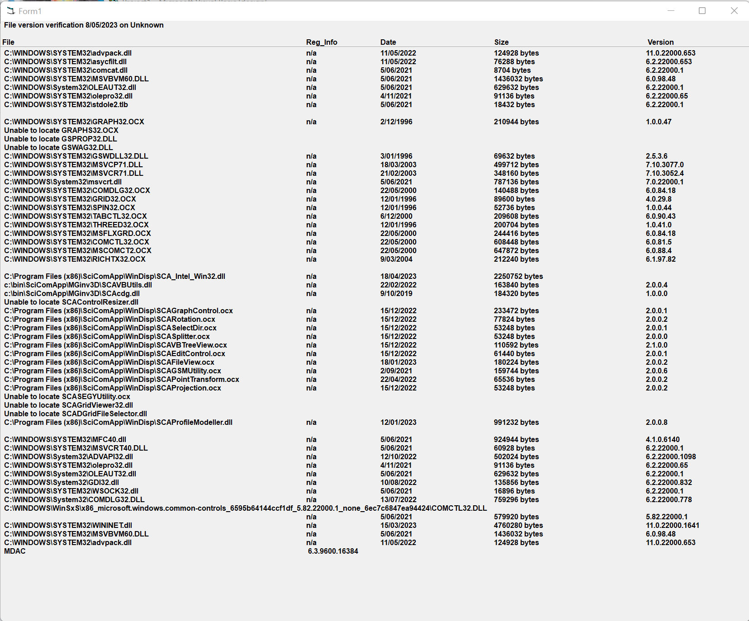

SciCoMap Files test This tests that all required files are valid
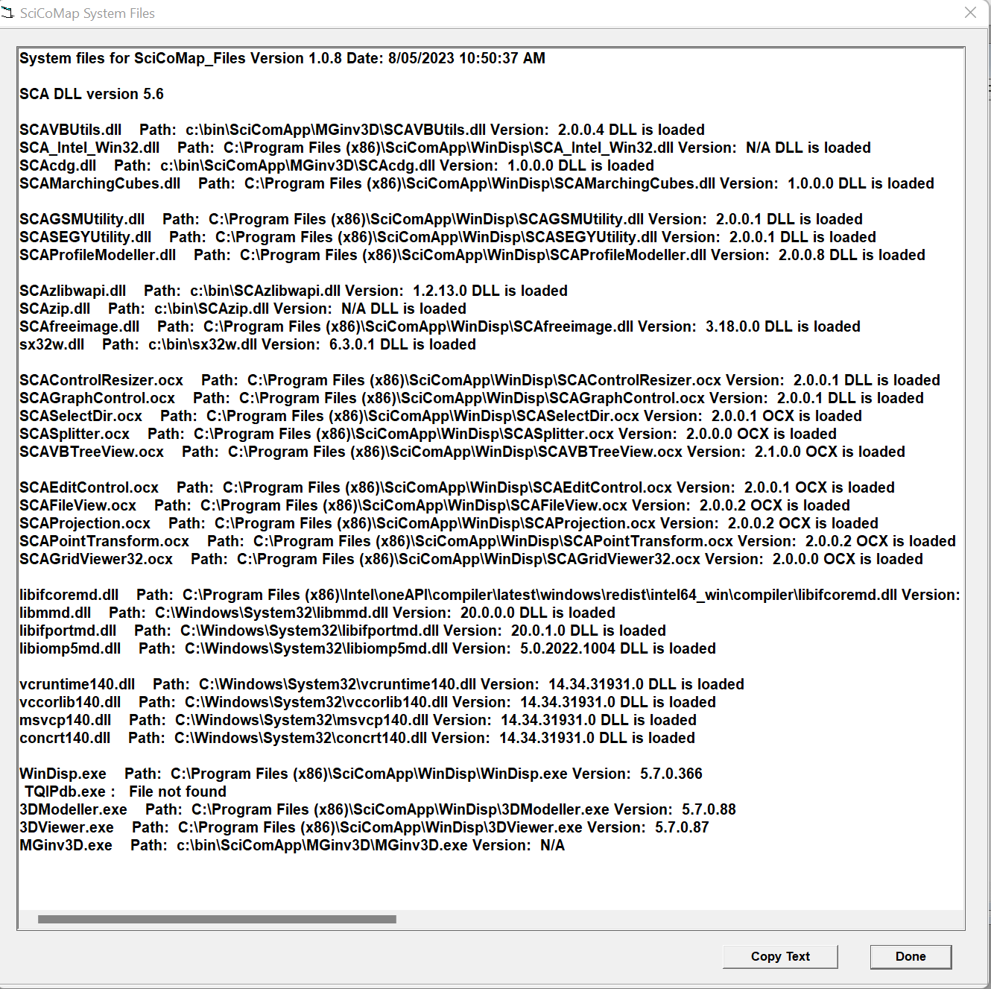

SciCoMap_Environment This checks all of the common SCA saved environment settings
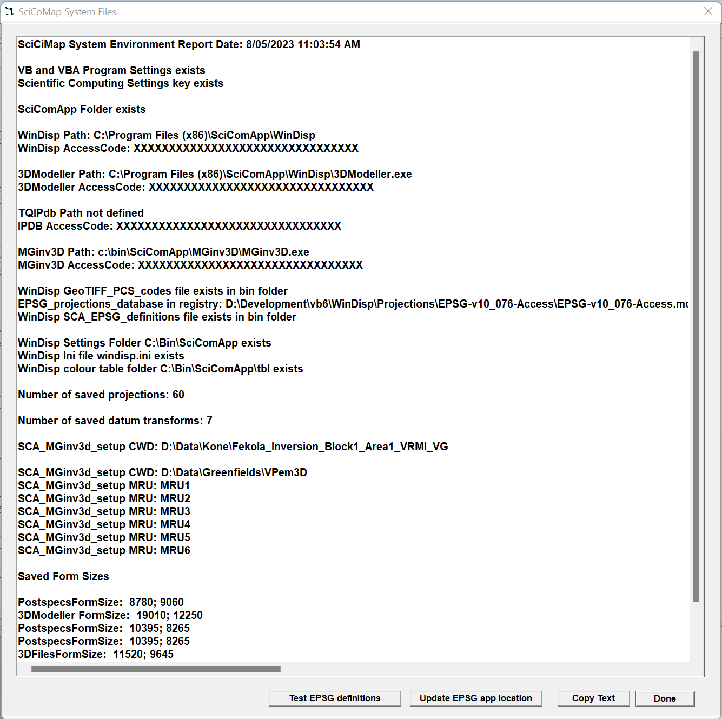
Geosoft DLLVer test This checks that all of the Geosoft 6.3 API files required are loaded on the system and creates a log file named Geosoft_DLLver.log in the folder where it is run
